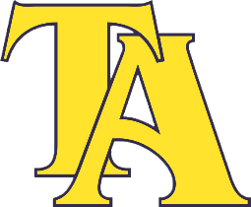

2020 Track and Field Schedule

February 28 University of Montevallo

March 11 John Carroll High School

March 21 Lee Scott Academy

April 9 & 10 AISA State Track and Field Meet

