AP LANGUAGE AND COMPOSITION
SUMMER READING

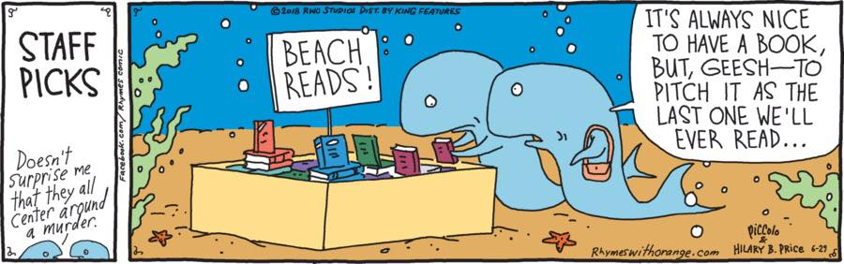

The AP Language and Composition course is intended to prepare students with the skills earned in an introductory college composition course. The curriculum is targeted to develop evidence-based argumentation and critical reasoning through careful analyses of nonfiction texts. Over the course of the school year, we will focus on understanding how writers form their arguments and what rhetorical situations are involved in informing those decisions.

In order to best prepare you for the final AP Examination, you will need to cover some of the material on your own before we gather in the fall. Namely, you will read three nonfiction works this summer: one research-based work, one narrative nonfiction work, and one mandatory class reader on effectively reading nonfiction.

For each reading, you will be asked to complete an assignment outlined below each selection list. These assignments are meant to aid you in (1) providing material you can reference when preparing for the AP Exam, (2) supplying you with references for in-class discussions, (3) giving you a head start on the first assignment of the fall semester which will be based off these readings.
Please note: Since AP English Language is a college-level course, the books on these lists contain college-level reading material. Some of the books include graphic situations, violence, and language, which some may consider offensive. I’ve provided links to each of the books’ Amazon pages so that you can read their synopses and reviews for yourself. You are free to make selections that are appropriate for you and your comfort level.
All Readings and Assignments will be due at the end of the first week of classes.
Reading 1: Required Reading

Foster, Thomas. How to Read Nonfiction Like a Professor: A Smart, Irreverent Guide to Biography, History, Journalism, Blogs, and Everything in Between. HarperCollins, 2020.

Assignment 1:
For each chapter, you will want to answer the following:
- The chapter’s main point
- A quote that you feel demonstrates the main point
- One thing you learned
- One thing that confused you/you want to think about further
- 1-2 discussion questions relevant to the chapter’s topic

Reading 2: Choose ONE of the following Research-Based Books:

Acemoglu, Daron and James A Robinson. Why Nations Fail: The Origins of Power, Prosperity, and Poverty. Random House, 2013.
- Topics: economics, government, international relations

Alexander, Michelle. The New Jim Crow: Mass Incarceration In The Age of Colorblindness. The New Press, 2010.
- Topics: mass incarceration, prison reform, race

Ehrenreich, Barbara. Nickel and Dimed: On (Not) Getting By In America. Picador, 2011.
- Topics: class, wages, poverty

Fainaru-Wada, Mark. League of Denial: The NFL, Concussions, and The Battle for Truth. Crown Archetype, 2008.
- Topics: football, health, CTE

Schlosser, Eric. Fast Food Nation: The Dark Side of the All-American Meal. Mariner Books, 2001.
- Topics: food, health, class

Weisman, Alan. World Without Us. Picador, 2008.
- Topics: Environment, science

Assignment 2:
- Decide what the central argument of the book is
- Choose at least 10 passages that show how the author supports their argument
    - i.e. quotes that demonstrate they are correct in their opinion with either facts, statistics, anecdotes, etc.
- Choose at least 5 passages where the author addresses people who disagree with them
    - Consider – how does the author demonstrate why others disagree with them without making it seem like the other side is right?
- Outline any bias the writer might have in arguing his/her topic
- What events prompted the writer to argue this when they did? Are they explicitly stated or did you have to infer?
- You should make general notes in the text while reading
    - What stands out to you
    - What confuses you

Reading 3: Choose ONE of the following Memoirs/Narrative Nonfiction works:

Angelou, Maya. I Know Why the Caged Bird Sings. Random House, 2009.
- Topics: Race, Gender, Class

Bryson, Bill. A Walk In The Woods: Rediscovering the Appalachian Trail. Broadway Books, 2010.
- Topics: Nature

Copote, Truman. In Cold Blood. Vintage, 1994.
- Topics: True Crime

Karr, Mary. The Liar’s Club. Penguin Books, 2005.
- Topics: Texas, Humor, Dysfunctional Families

Laymon, Kiese. Heavy. Simon & Schuster, 2018.
- Topics: Family, Eating Disorders, The South

Sedaris, David. Naked. Back Bay Books, 1997.
- Topics: Humor, Family, Essays

Ung, Loung. First They Killed My Father: A Daughter of Cambodia Remembers. Harper Perennial, 2006.
- Topics: Genocide, Family, Coming of Age

Assignment 3:
- Decide who the author is writing for (who is their audience? It’s probably more than one person/group.)
  - Quotes/passages/word choice that makes you think this
- After each chapter, answer:
  - What does the author want to make me feel?
    - Quotes/passages/word choice that makes you think this
  - What is the setting and tone of the chapter?
    - Quotes/passages/word choice that makes you think this
  - Quotes the author makes with Ethos/Pathos/Logos.
  - Ethos – author relies on credibility (states certifications, degrees, governmental bodies, etc.)
      - The Director of the CDC states, …..
      - As a life-long lover of art, I know that….
      - I’ve lived in this place my whole life…
  - Pathos – author appeals to emotions (humor, anger, love, sadness, etc.)
      - the Sarah McLachlan ASPCA commercials
      - language that’s very flowery or feel-good
      - aggressive punctuation
  - Logos – author relies on logic (statistics, numbers, if/then statements, etc.)

